Our October Visit Prospect Point, Blue Mtn. NY, - October 2018

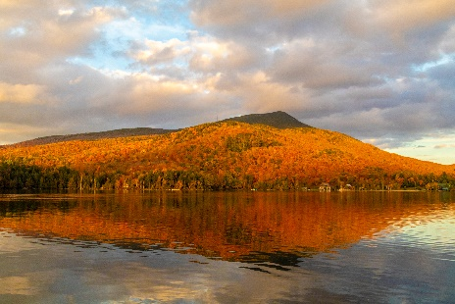This was our first visit to [Prospect Point Cottages](http://prospectpt.com/) on Blue Mountain Lake, NY this October to once again experience the beauty of the NYS wilderness. During our week there, we thoroughly enjoyed the morning brunch - truly a brunch to die for with a wide variety of hot and old fresh deliciously choices. Most satisfying. While the weather was cool, windy, and “ocassionally” wet, we kept active with daily hiking, kayaking, and restful reading. Several water runs expanded our fond memories of paddling in the rain and we fine tuned our skills of paddling long distances in strong variable winds. An excellent week! We shall return next year…

And for the photos, click [Prospect Point – October 2018](https://photos.app.goo.gl/K5ktHcZGNGgZUe9NA).